Ques.1. Combine Two Tables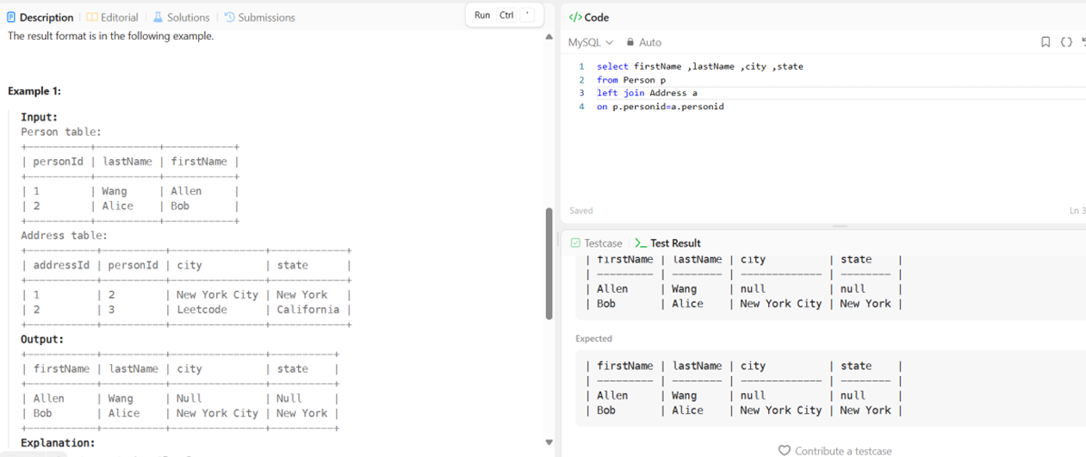
Ques.2. Second Highest Salary 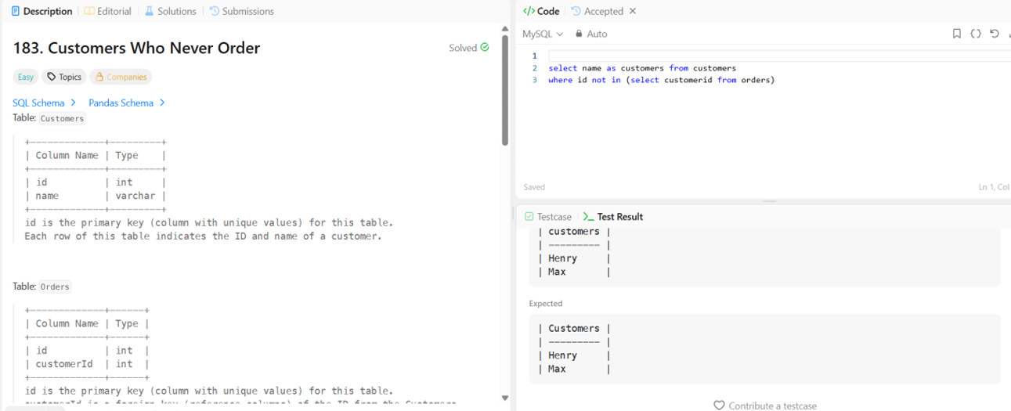Ques.3. Customers Who Never Order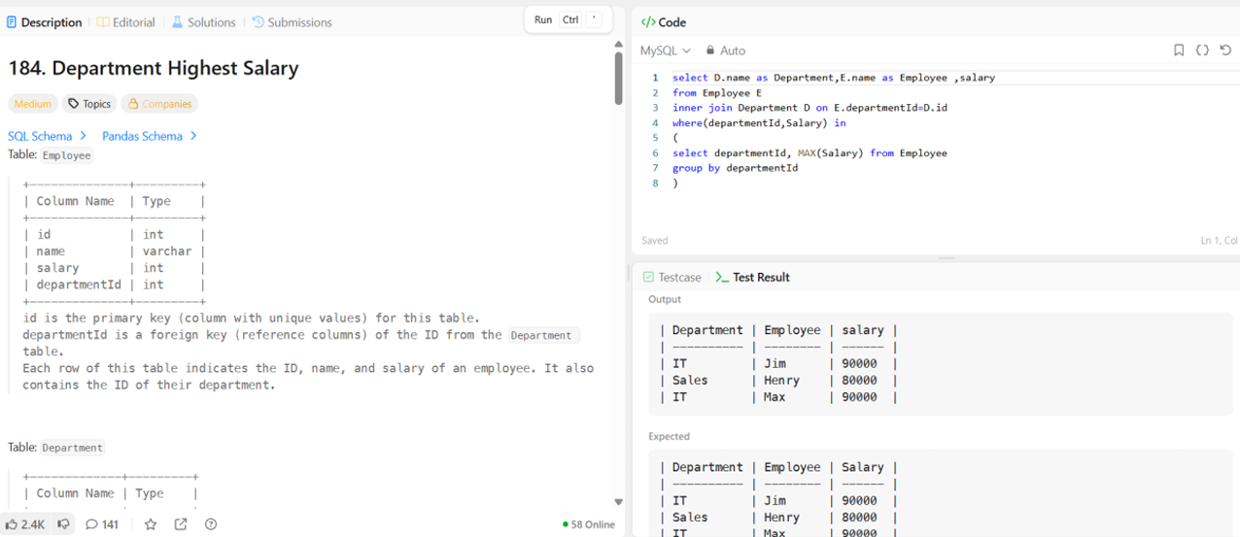Ques.4. Department Highest Salary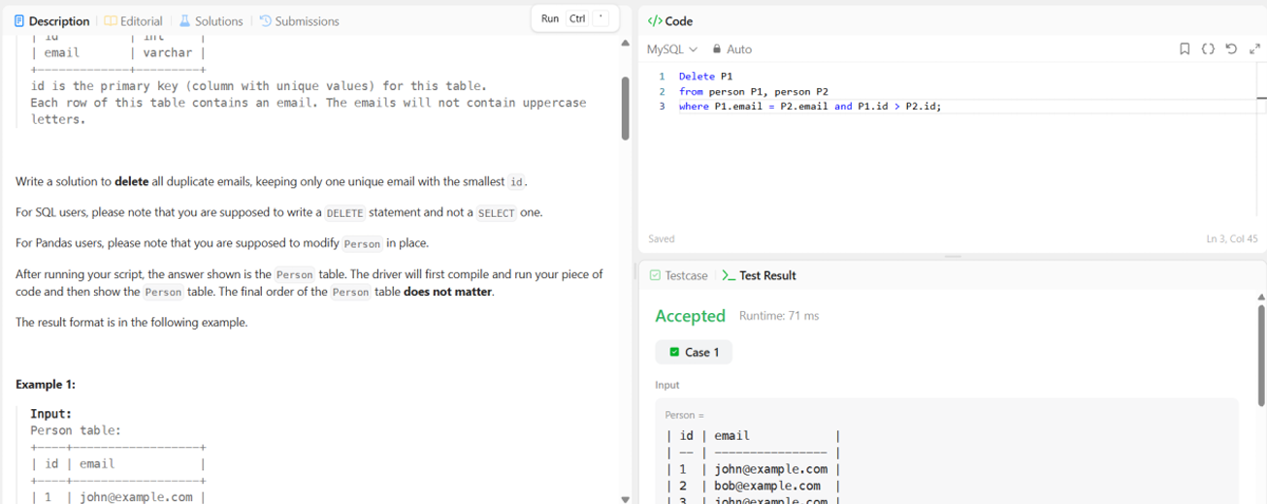Ques.5. Delete Duplicate Emails 